**Curriculum Vitae**

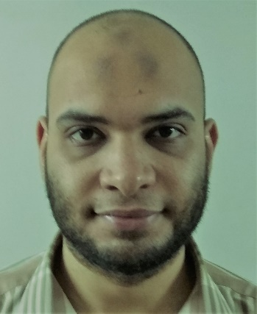**Personal data:**

**Name :** **Hythem Mohamed Ahmed Mohamed.**

**Birth date :** February 25th, 1989.

**Gender :** Male.

**Place of birth** : Assiut, Egypt.

**Nationality** : Egyptian.

**Marital status :** Single.

**Military status** : Exempted.

**Address:** ***Assuit - El Sadat - Obour street***

**Telephone :**  **- Home: 0882331694**

**- Mobile: 01067330721**

**E-mail** Hythemmoh@yahoo.com

hythemmoh@aun.edu.eg

**Present occupation:**

* Assistant Lecturer - Department of Anesthesiology, Intensive Care, Faculty of Medicine, Assiut University Hospitals – Assiut - Egypt.
* Part of Liver transplantation anesthesia team since 2017.
  + Registered at the Egyptian Ministry of Health.

**Academic Record:**

|  |  |
| --- | --- |
|  |  |
| March 2017 | Master Degree in Anesthesia from Assiut University signed up with "Very Good", with thesis titled **“**Effects Of Caudal Fentanyl Supplemented With Bupivacaine On Blocking Hernial Sac Traction Response In Children Undergoing Inguinal Hernia Repair***.”*** |
| Oct. 2014 | First part of master degree in Anesthesia, ICU, and Pain management signed up with "*excellent*" studying anatomy, physiology, pharmacology, physics & internal medicine. |
| Sept. 2011 | M.B.B.Ch. degree in medicine & surgery from Assiut University, Faculty of medicine, signed up "*very good with honor*, ranked 98 among the 610 medical students in my college. |
| 2005 | Graduated from High School with score 99.5 % |

**Professional Record:**

|  |  |
| --- | --- |
| March 27th 2017 – till now  September 1nd, 2015 – March 26th 2017 | Assistant Lecturer, Department of Anesthesia,  Assiut University Hospitals, Assiut, Egypt.  Demonstrator, Department of Anesthesia, Assiut University Hospitals, Assiut, Egypt.  (Residency training continues) |
| March 7th, 2013 – August 31st, 2015 | Resident of Anesthesia, Assiut University Hospitals, Assiut, Egypt. |
| March 1st, 2012– February 28th, 2013 | House officer at Assiut University Hospitals, Assiut, Egypt. |

**Languages:**

* **Arabic:** Mother tongue.
* **English:** good.

**Personal Skills:**

* **Self-learning**
* **Hard working**
* **Team work**
* **Work under stress**

**Computer skills:**

* **Sufficient computer skills** without certificates on Microsoft word, Microsoft powerpoint.

**Summary of Duties:**

***March 7th,2013 – August 31st, 2015:***

Working as a resident doctor in Assuit university hospital including:

* Attending 6 operative lists per week covering all anaesthetic specialities and subspecialties, attending the preoperative surgical fitness clinic once per week.
* Attending a casualty roaster every two days supervised by an assistant lecturer.

***Additional Duties (2013 – present):***

-  Teaching graduate students along the house officer- training program at our department.

-   Helping in the achievement of goals of the residency program of training along the 3 years of residency.

-    Helping in the research program held at our department with colleagues and professors.

- Chosen to be a member of Liver transplantation anesthesia team since 2017.

|  |
| --- |
| **Hobbies:**   * Playing football, swimming, gym * Traveling. * Chess. * Social networking. * Hanging out with friends. |

**Training courses:**

|  |  |
| --- | --- |
| 2012 (During House officer training year) | *Surgical Suturing course.  *Ethical & law consideration in medical practice.  *CPR Course.  *Infection control course. |
| April 2015 | **ACLS (Advanced Cardiovascular Life Support) provider course:** Advanced professional course given by AHA (American Heart Association) with course certificate valid for 2 years. |
| August 2016 | *Infection control workshop.  *Evidence based medicine course.  *Medical reports workshop. |
| March 2017 | My research paper got acceptance to be published in Journal of Current Medical Research and Practice “**Effects Of Caudal Fentanyl Supplemented With Bupivacaine On Blocking Hernial Sac Traction Response In Children Undergoing Inguinal Hernia Repair**" |
| April 2017 | I got registered to do my doctorate at Assiut university |
| August 2017 | ATLS provider course course certificate valid  for 4 years |
| April 2018 | Attended the 34th International annual Egyptian anesthesia conference. |